TABLE OF CONTENT

PAGES

1. INTRODUCTION, PROBLEM DEFINITION & PROPOSED SOLUTION…………………………………………………………………………………2-3

2. SYSTEM DEVELOPMENT LIFE CYCLE (SDLC)……………………………………4-7

3. SYSTEM ARCHITECTURE DESIGN…………….…………………………………8-10

4. PROTOTYPE DEVELOPMENT…………………………………………………..…11-12

5. PROJECT PLAN………………………………………………………………………13-14

6. License, Design Quality & SDG Relevance…………………………………….15

7. CONCLUSION & REFERENCE……………………………………….………………16

SMART HOSPITAL MANAGEMENT SYSTEM

1. Introduction
Healthcare institutions often face challenges in managing patient information, appointments, and medical records efficiently. Many hospitals still rely partly on paper-based processes, which can lead to misplaced records, delays in accessing patient information, and inefficient service delivery.
To address these challenges, this project proposes a Smart Hospital Management System that digitizes hospital operations and improves communication between patients, doctors, and administrators. The system provides a centralized platform for managing appointments, medical records, and healthcare services.

2. Problem Definition
Hospitals handle large amounts of patient information daily. Traditional methods of managing records and appointments can be time-consuming, prone to human error, and difficult to maintain. Patients may experience long waiting times, misplaced records, and delays in receiving medical services.
The absence of a centralized digital system can negatively affect the quality of healthcare delivery and reduce operational efficiency. Therefore, there is a need for a system that automates hospital processes and improves access to healthcare information.

3. Proposed Solution
The proposed Smart Hospital Management System is a digital platform designed to manage hospital activities efficiently. The system enables patients to register, book appointments, and access medical records. Doctors can view patient information and update medical records, while administrators manage users, doctors, and reports.
The system improves healthcare service delivery by reducing paperwork, increasing data accessibility, and improving communication among stakeholders.

4. SYSTEM DEVELOPMENT LIFE CYCLE (SDLC)
The Smart Hospital Management System will be developed using the Software Development Life Cycle (SDLC) model. SDLC provides a structured approach to planning, designing, developing, testing, and maintaining the system.

1. Planning Phase
In this phase, the project goals and requirements are identified. The need for a system that helps patients, doctors, and administrators manage hospital services efficiently is established.
Activities:
- Identify project objectives.
- Define scope of the system.
- Determine resources and timeline.
- Prepare project plan.
Output: Project proposal and project plan.

2. Requirements Analysis Phase
The requirements of users are collected and analyzed.
Activities:
- Identify patient requirements (appointment booking, medical records, profile management).
- Identify doctor requirements (view appointments, update medical records).
- Identify administrator requirements (manage users, manage doctors, generate reports).
- Document functional and non-functional requirements.
Output: Software Requirements Specification (SRS).

3. System Design Phase
The overall structure and design of the system are created.
Activities:
- Design system architecture.
- Create database structure.
- Develop user interface prototypes using Figma.
- Design navigation flow between screens.
Output: Architecture diagram, database design, and Figma prototype

4. Development Phase
The actual coding and implementation of the system take place.
Activities:
- Develop patient module.
- Develop doctor module.
- Develop administrator module.
- Create database and connect system components.
Output: Working Smart Hospital Management System.

5. Testing Phase
The system is tested to identify and fix errors.
Activities:
- Test login and registration functions.
- Test appointment booking.
- Test medical records management.
- Test administrator and doctor functions.
- Fix detected bugs.
Output: Tested and reliable system.

6. Deployment Phase
The completed system is released for use.
Activities:
- Install system on hospital servers.
- Configure user accounts.
- Make the system available to patients, doctors, and administrators.
Output: Operational Smart Hospital Management System.

7. Maintenance Phase
After deployment, the system is monitored and improved.
Activities:
- Fix errors discovered after release.
- Update security features.
- Add new functionalities when needed.
- Improve system performance.
Output: Updated and improved system.

Conclusion
By following the SDLC model, the Smart Hospital Management System can be developed in an organized manner, ensuring that it meets user requirements, maintains quality, and supports efficient healthcare service delivery.

5. SYSTEM ARCHITECTURE DESIGN

Figure 1: SYSTEM ARCHITECTURE DESIGN

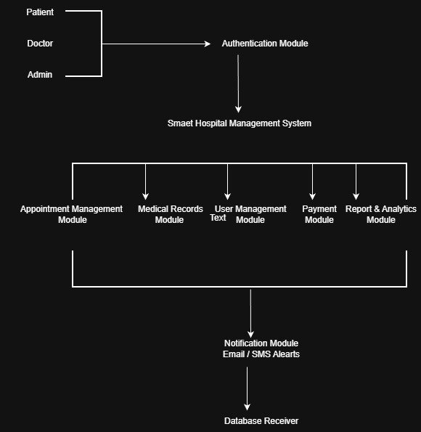

Explanation of Components

Patient
- Registers an account.
- Books appointments.
- Views medical records.
- Checks appointment history.

Doctor
- Views appointments.
- Accesses patient records.
- Updates diagnoses and treatments.

Admin
- Manages users.
- Manages doctors.
- Generates reports.
- Controls system settings.

Hospital Management System
This is the main application that:
- Processes requests.
- Stores patient information.
- Manages appointments.
- Generates reports.

Database
Stores:
- Patient records.
- Doctor records.
- Appointment information.
- User accounts.

2. Explain How Components Interact
1. Patients, doctors, and administrators access the system through the Authentication Module.
2. The Appointment Management Module handles appointment booking and scheduling.
3. The Medical Records Module stores and retrieves patient health records.
4. The User Management Module manages accounts and access rights.
5. The Payment Module processes payments .
6. The Reports & Analytics Module generates reports for administrators.
7. The Notification Module sends reminders and updates.
8. All modules interact with the Database Server for storing and retrieving information.

3. Prototype Development
The user interface prototype was developed using Figma. The design focuses on simplicity, usability, and consistency.
The prototype contains the following screens:
- Login Screen
- Register Account Screen
- Patient Dashboard
- Book Appointment Screen
- Medical Records Screen
- Appointment History Screen
- Doctor Dashboard
- Admin Dashboard
- Reports and Statistics Screen
- Profile Settings Screen

Figure 2: Smart Hospital Management Prototype Screens Designed in Figma
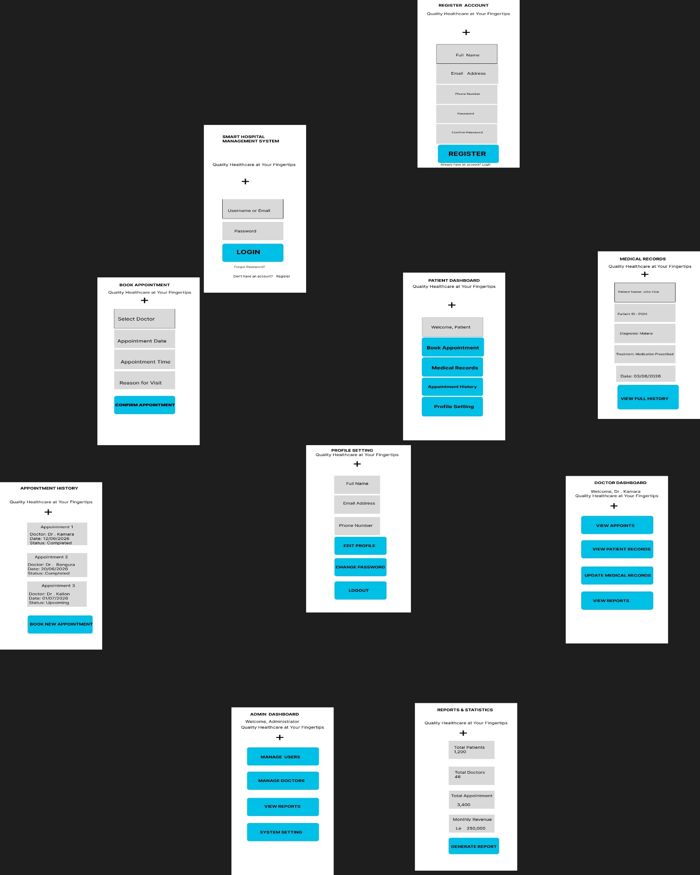
6. Project Plan

Figure 3: Gantt Chart
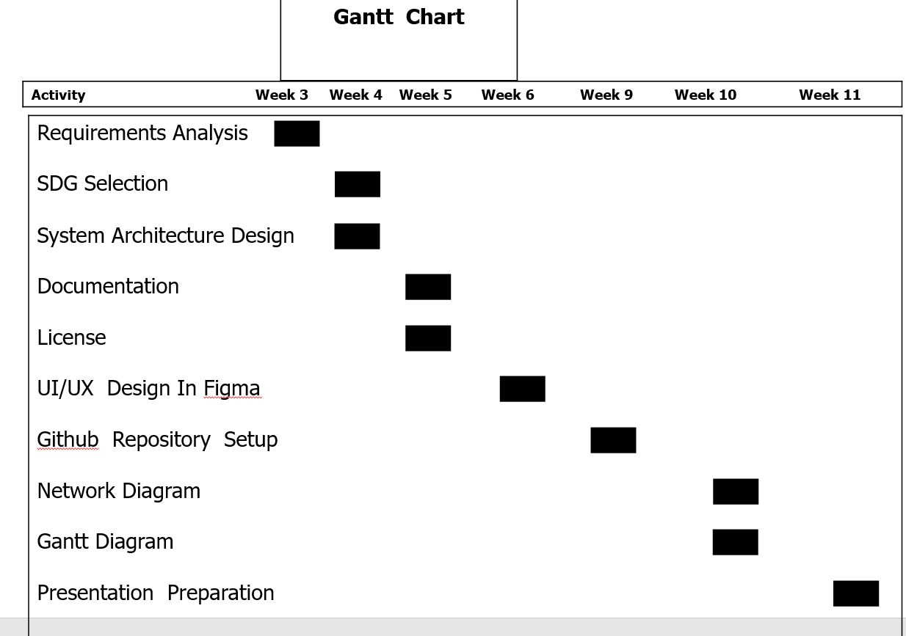

Figure 3: Project Network Diagram
Activity Precessor Duration
A - 3
B A 4
C A 4
D A 5
E B,C,D 5
F E 6
G F 9
H G 10
I G 10
J H,I 11

49

3
3
0
0
7
8
4
3
7
8
3
4
8
8
3
3
13
8
8
13
13
19
19
13
28
28
19
19
38
38
28
28
38
38
28
28
38
49
49
38
A (3)
B (4)
C (4)
D (5)
E (5)
F (6)
G (10)
H (10)
I (10)
J (11)

8. Software License
This project uses the MIT License.
The MIT License allows users to use, copy, modify, distribute, and share the software while providing appropriate credit to the original developers. The license was selected because it is simple, flexible, and encourages collaboration and future improvements.

9. Design Quality (UI/UX)
The user interface was designed with a focus on usability and consistency. Clear navigation menus, readable text, organized layouts, and consistent visual elements were used throughout the prototype.
The design ensures that patients, doctors, and administrators can easily access system features and perform tasks efficiently.

SDG Relevance
This project aligns with Sustainable Development Goal 3 (Good Health and Well-being). The system contributes to improved healthcare services through efficient management of patient records, appointment scheduling, and communication between healthcare providers and patients.
By digitizing hospital operations, the system supports better healthcare outcomes, reduces delays, and enhances access to medical information.

10. Conclusion
The Smart Hospital Management System provides a digital solution for managing hospital operations. The system improves appointment scheduling, patient record management, and communication among stakeholders.
By supporting SDG 3 (Good Health and Well-being), the project contributes to improved healthcare delivery and demonstrates how technology can be used to solve real-world healthcare challenges.

11. References
- United Nations. Sustainable Development Goal 3: Good Health and Well-being.
- Figma Design Tool Documentation.
- GitHub Documentation.
- Software Engineering and System Analysis course materials.
- MIT License Documentation.

